
This CREST training program is funded by a Grant from the Department of Transportation and designed specifically to address shipping and handling of dangerous goods in the Railroad industry. Classes can be presented at any location designated. Worker-instructors who complete a five day course are tasked with training others using one-on-one informational sessions, 1 hour and/or 15 minute presentations on site. Many employers are participating in the training program simply to enhance their existing training programs. 1-967-4704
Hazardous Materials Worker Enhancement Awareness Training
On The Railroad There Are No Small Incidents!
CREST DOT Hazardous Materials Train the Trainer Programs are designed specifically for the Railroad industry, helping to enhance existing training programs employers already have in place.
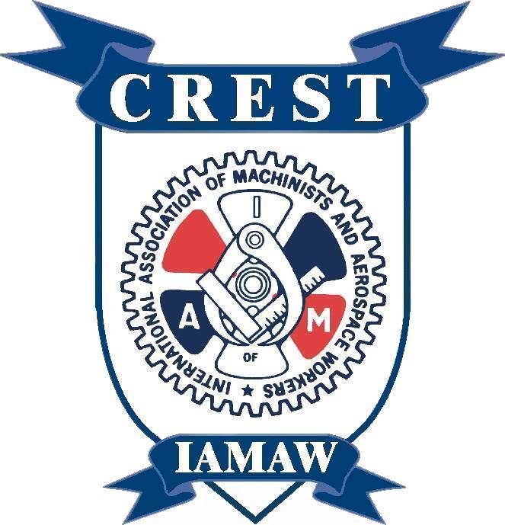 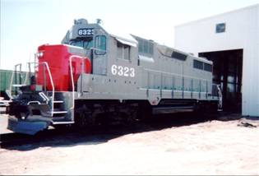  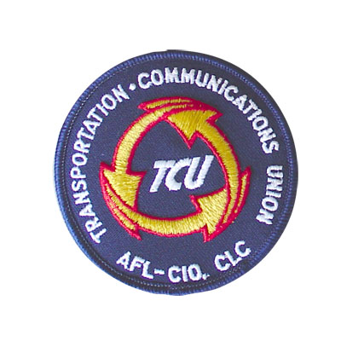 For more program information or if you are interested in becoming
an instructor, contact IAM CREST at 301-967-4704 or go to: hazmatworkerrailtransport.com

