2026 Departmental Program
Participant Registration Form
William W. Winpisinger Education and Technology Center

Mandatory - The following information must be filled in
Advanced Local  Chairman Development | August 22, 2026-  August 28, 2026
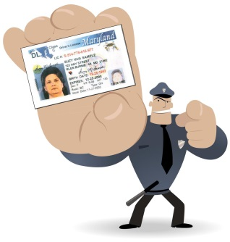
“Pull out your Driver’s License.”

Full Legal Name (as printed on your ID)
Verify your name is as it appears on your Driver’s License or Passport that you are presenting as identification at the airport.
First Name: __________________________________ Middle:__________________
Last Name: ___________________________________________________________
Nickname: _______________________ Date of Birth: _________________________
Title: __________________ Local Lodge: ____________ District Lodge: __________
Gender: ________________________ Territory: ____________________________
Mailing Address: _______________________________________________________
Province/ Postal Code/
City: ____________________________State: ___________Zip Code:_____________
Home Phone:______ - ______________Work Phone:_______ - ________________
Cell Number:______ - ______________ IAM Book No.: _______________________
E-Mail Address: _______________________________________________________
Carrier:_______________________________________________________________

Program: Advanced Local Chairman Program August 22-28, 2026

All enrollment forms must be processed through the District 19 Tennessee Office

Please email this form to Cheryl Lane at cheryl.lane@districtlodge19.com or fax it to
865-269-4611 as soon as possible as space is limited.

Please direct all questions regarding the program to District 19 Educator Jason Gibbs
@ 615-485-8646 or jgibbs@districtlodge19.com

